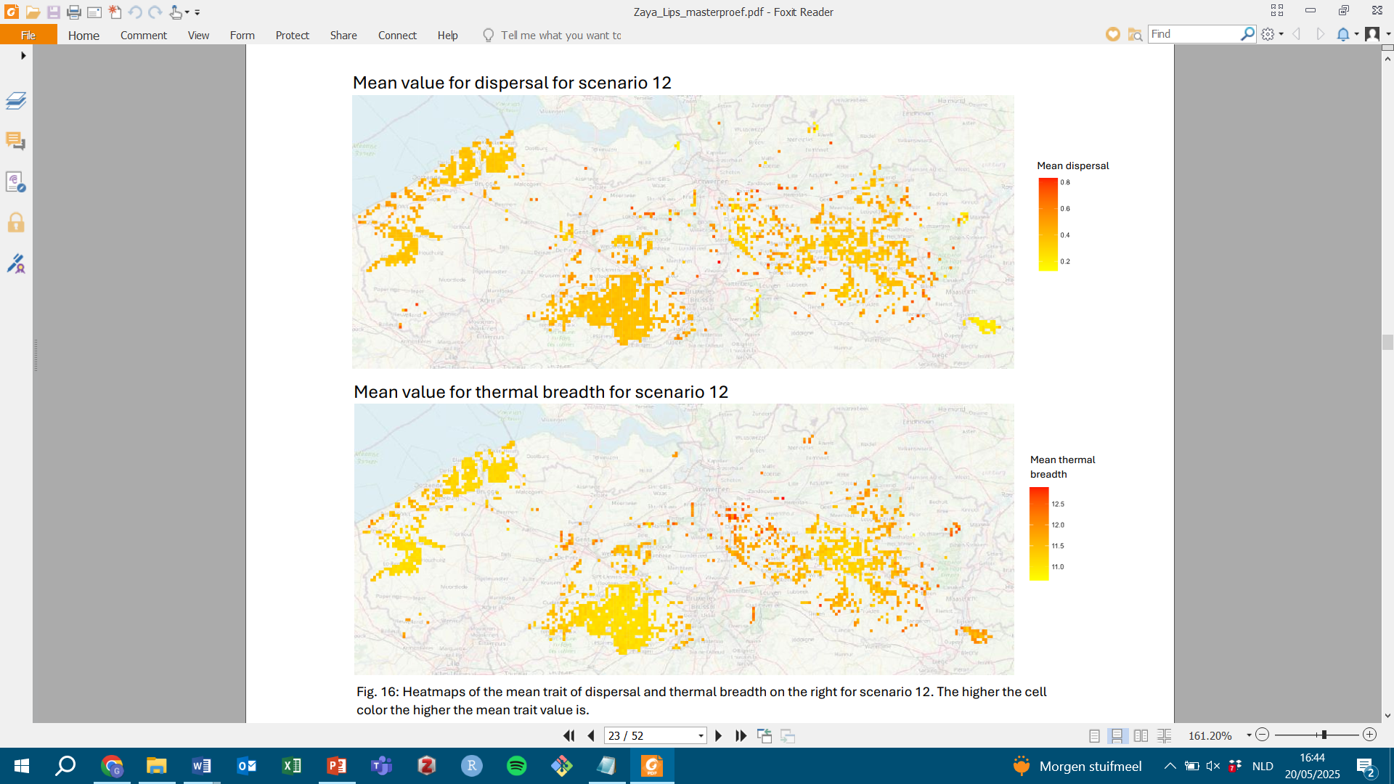
S.6.4 Trait heatmaps
(a)
(b)
Figure S.6.4: heatmaps showing mean trait values for (a) dispersal and (b) thermal breadth at the cell level in the all grassland landscape at temperature 15.05 °C. Darker colours indicate higher trait values.

